**Heritage Planning for Sustainable Cultural Impacts**

By Douglas Worts - member, AASLH Sustainability Task Force

April 2019

**NOTE**: a shortened version of this article was first published on the AASLH Blog site ([**click here**](https://aaslh.org/sustainable-cultural-impacts/)).

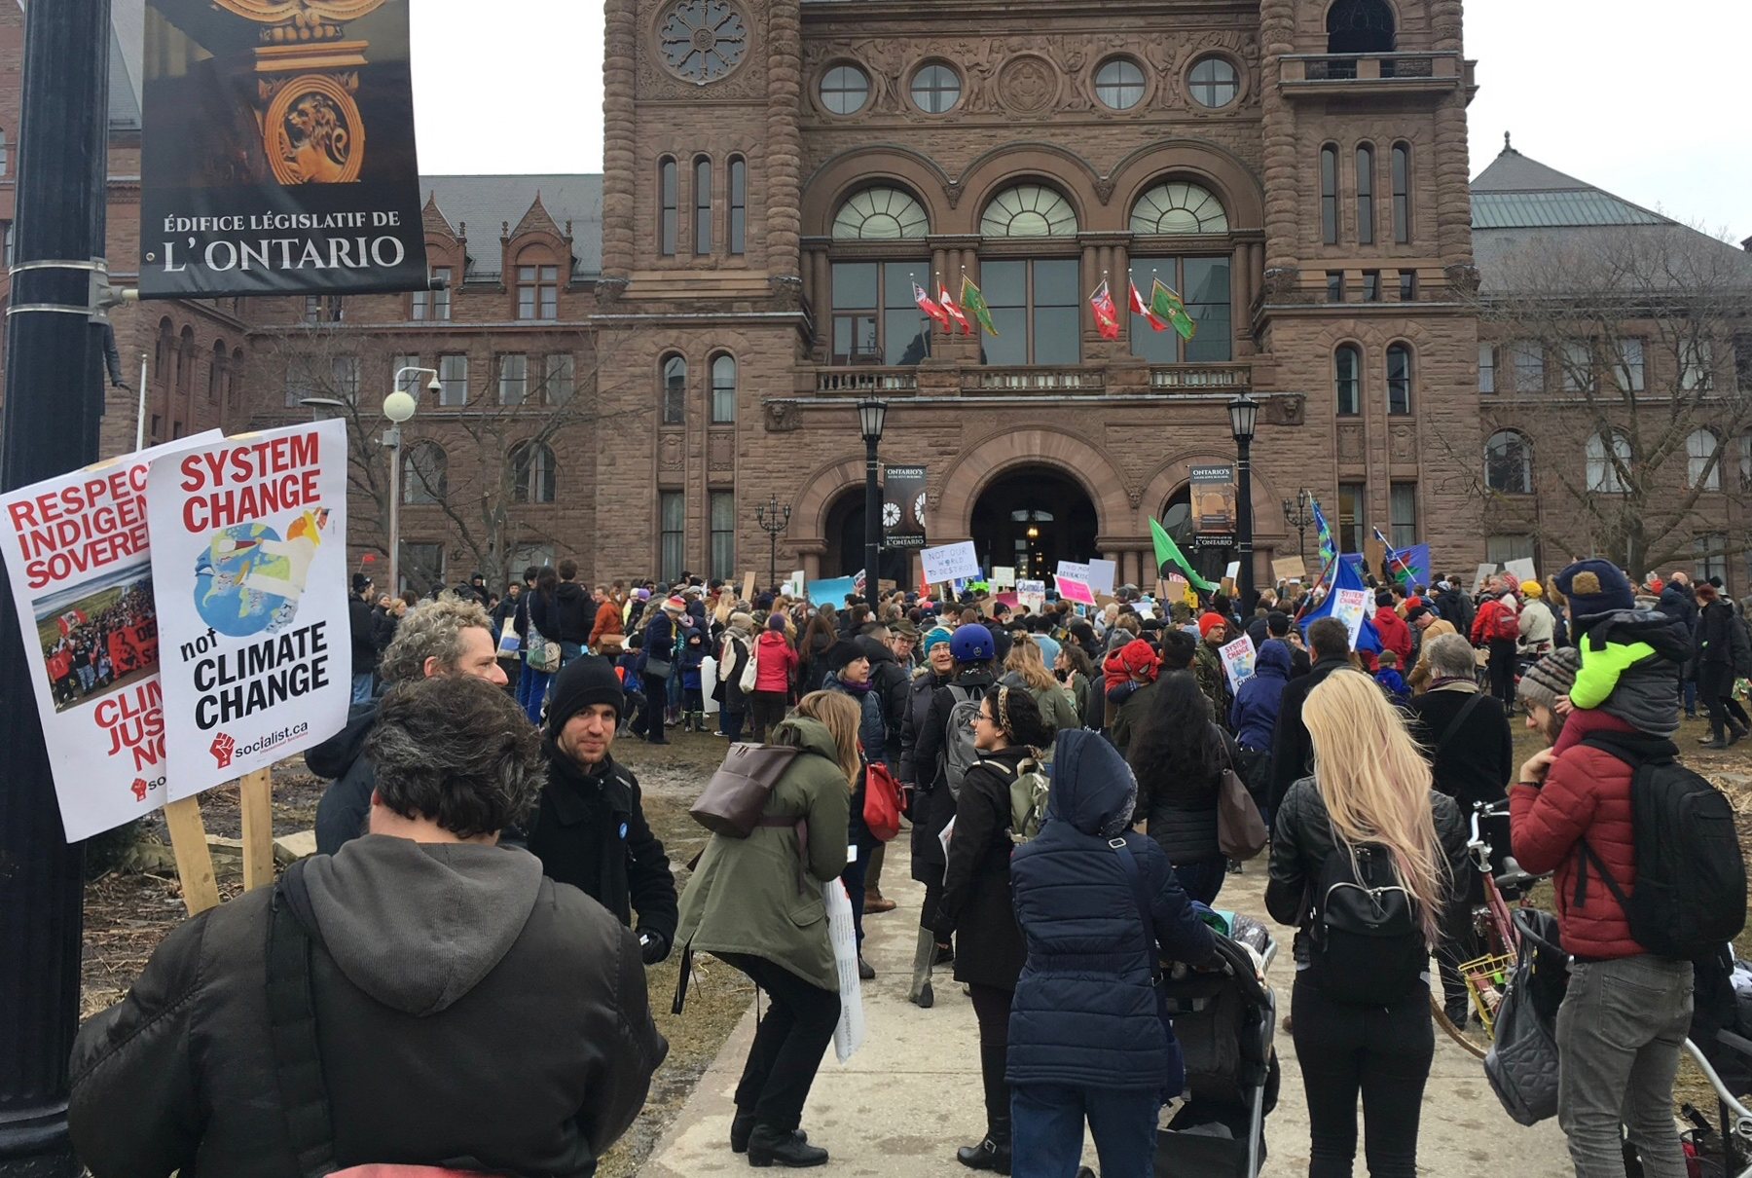

Figure 1. Fridays for Future Protest, Toronto, March 2019, Photo: DCW

AASLH President & CEO, John Dichtl, has written an inspiring post in his column for *History News,* and reproduced on the AASLH blog site ([**CLICK HERE**](https://aaslh.org/history-and-climate-change/)) - one that is appropriate to this moment in time for our culture. He paints a big picture related to the phenomenon of climate change, asserting a cause/effect relationship between human culture and our transforming climate. John invokes insights coming from history, science and social science - three pillars of human knowledge creation - as being capable to helping to guide humanity through treacherous waters into the future.

In his call to action, John suggests that the heritage sector can and should embrace climate change as a focus for our public engagement efforts. Similar to how our sector has focused on the vital topics of equity, diversity and justice in our society, climate change belongs on that list of essential issues of our time. His assertion that history and related disciplines provide a solid, evidence-based foundation that is driven by a pursuit of truth, is a strong argument for enhancing the roles of heritage organizations in grappling with the forces that are shaping contemporary culture. Certainly current trends in using false statements to manipulate citizens and governments are worrying. Not only are false statements dishonest, but they are divisive and promote violence. Humanity has more than enough to deal with at this point in time, without the chaos produced by normalizing fictional facts. If humanity has a chance of achieving a sustainable future, we must build and maintain a solid foundation of values and behaviours that are guided by a common understanding of the difference between truth and falseness.

John makes many good points about the heritage field needing to embrace the challenges of dealing with climate change. Certainly extreme weather events do threaten to damage the physical fabric of museums and other cultural facilities. Protecting existing properties, collections, archives and other assets is important. Such activities however, need to be seen within the larger context of the leadership role that our sector can play as catalysts of cultural change and adaptation across society. The critical process needed to manage the complexity and scope of current challenges and opportunities is the effective use of ‘systems thinking’.

Climate destabilization, like racism, inequality and injustice, are all symptoms of bigger and deeper problems. The situation is not unlike going to a doctor because you have trouble breathing. After some tests, and a confirmation that pneumonia is present, it is relatively straight-forward to treat the illness. However, it is vital to determine whether the lung disease is a primary or secondary condition. If there is an underlying cancer that caused the pneumonia, it is essential that all efforts are taken to treat the cancer, at the same time that the pneumonia is being treated. When mapping the causes of a changing climate, it is clear that climatic changes are driven to a large extent by greenhouse gases (GhGs). Most people have learned that GhGs come from many sources, but mostly the burning of petroleum products. And it is human demand for energy and the corporate need for wealth generation that are the drivers of fossil fuel use. Our society seems determined to retain its reliance on unfathomable amounts of energy required to power transportation, housing, manufacturing, and so much more. So what can heritage organizations do? If they were able to leverage insights from how humans in the past have navigated crises in the past, then the old saying ‘we stand on the shoulders of ancestors’ could be applied in ways that help the living culture to adapt to our changing world. Such a scenario would require considerable innovation within the cultural field, and it would feel uncomfortable. It would be similar to the doctor who, while treating a lung disease, discovered an underlying cancer, would need to call in other specialists.

As humanity grapples with the prospect of widespread climate destabilization, humans have a few options:

1. dramatically reduce consuming energy as we do;
2. find a substitute approach providing energy, specifically renewable energy; or
3. continue business as usual and make the world uninhabitable for humans.

If existing energy corporations embraced the option of transforming the global energy system (e.g. through a transition to renewables), then a huge amount of time could be secured to rethink how humanity can live successfully on this planet. Since oil companies and their investors, as well as governments and many customers do not seem prepared to exercise this leadership option, a crisis simply gets more serious. It is like ignoring an underlying cancer. Who would have thought that so many people in our world would be so resistant to recognizing a crisis, especially with all the scientific evidence being clear? Bridging this gap between reality and understanding/belief is fundamentally a cultural challenge. Not the kind cultural organizations are used to - but increasingly the ones that require being addressed.

The heritage sector has the ability to foster conscious cultural change as demonstrated by its many amazing attributes, including the heritage and cultural sector:

* extends across the country and around the world
* operates in virtually in every community
* enjoys close links to the general public
* maintains a very high level of public trust
* is solidly rooted in many disciplines that are based on rational, evidence-based knowledge and continuous improvement through research
* are the custodians of a large quantity of culturally significant tangible and intangible heritage, all of which is invaluable for catalyzing and guiding our constantly-evolving culture.

In John’s post, he has emphasized the value of the heritage sector getting ahead of climate and weather trends that threaten to cause irreparable harm to individual sites and collections. This makes good sense. And, since climate change can be seen as an advanced case of pneumonia, which is a secondary condition to the primary problem of an underlying ‘cancer’, it is important to be using a systems thinking framework to deal with the complexity of this large, ‘wicked problem’.

If heritage and cultural organizations are seen as having potential as catalysts of cultural adaptation, then it is best to have a map of how to aim for two general types of positive impacts. As John has suggested, one refers to ‘inner’ transformations and impacts, while the other refers to public strategies that lead to ‘outer’ transformations and impacts. My goal with the model below is to offer a planning approach for heritage organizations to:

1. identify ways that will make existing resources as resilient as possible (INSIDE), and
2. offer a framework for how individual sites, in concert with a wide spectrum of potential values-aligned partner organizations (including progressive businesses, foundations, governments and so on), can become catalysts of public engagement and cultural change (OUTSIDE).



Figure 2. Outside-Inside Impact Model, DCW

At the heart of this model are the Heritage Organizations, which generate strategies, designed to have meaningful impacts. One group of these strategies may be designed to generate INSIDE IMPACTS - for example ones that improve energy efficiency, or reduce waste, such as CO2. Inner strategies also include acquiring new skill sets to develop capacity for working towards new kinds of outside strategies, such as conducting cultural needs analyses or impact studies. The second group of strategies are designed to generate OUTSIDE IMPACTS. This includes some traditional activities, such as programs to engage and impact individuals, families and groups. For many, new opportunities are suggested for impacts at the levels of communities, neighbourhoods, other organizations (both for-profits and non-profits) as well as cities. Each of these focuses will have different challenges and opportunities that will need to be assessed. Much experimentation and testing will be required for the field to fully move into these areas of catalyzing cultural change.

One of the notable aspects of this model is that the heritage sector, along with all of humanity, is contained within the natural environment. So whatever is done, by any part of human society, has direct impacts on Nature - all of which need to be understood and incorporated into the strategies. One example is that any organization that relies heavily on tourism for attendance, generates a large carbon footprint simply by its relationship to tourists and how they travel. Our sector has complex relationships, which provide challenges, but also great opportunities for cultural impacts. I hope that this model generates discussion and creativity on the question of ‘how can heritage organizations help facilitate adaptive cultural change, in a fast-changing world’?

***

Douglas Worts is a ‘culture and sustainability specialist’, living in Toronto, Canada. He has been a museum professional for over 40 years, focused variously on interpretive planning, audience research, education technologies and teaching museology. Since 1997, his main interest has been in the cultural dimensions of humanity’s unsustainability, and the potential role of museums to foster cultural and adaptive change.

website: [WorldViewsConsulting.ca](http://WorldViewsConsulting.ca)